09 90 00 - Painting Interior

All nail heads shall be set below the surface and finished smooth. Joints should be taped and covered with a suitable drywall joint compound. Sand the spackled nail heads and joint compound smooth and dust well before priming. Interior walls shall receive a primer coat and two coats of flat or semi-gloss paint. Surfaces shall be sanded before each finish layer is applied.

CEILING
Benjamin Moore Ceiling White (flat)
TRIM
Please select a interior trim color including all doors (Benjamin Moore)
Color:
WALLS
Please select five interior wall colors (Benjamin Moore)
PAINT #1 color: |  | finish:
PAINT #2 color: |  | finish:
PAINT #3 color: |  | finish:
PAINT #4 color: |  | finish:
PAINT #5 color: |  | finish:
ROOM | PAINT # | WALLPAPER? (+$) | COMMENTS
Stair Hall / Half Bath
Master Bedroom
Dining Room
Great Room
Kitchen / Pantry
Mudroom
Bedroom 1
Bath 1
Bedroom 2
Bath 2
Bedroom 3
Bath 3
Hallway
Laundry

09 91 13 - Exterior Painting

All nail and screw heads shall be set below the surface and finished smooth. Exterior shingle walls shall either receive a semi-solid or solid stain coat (California storm stain) for primed shingles or, for natural shingles, a transparent or semi-transparent stain. All unfinished wood trim pre-primed backside, edges and ends prior to installing. Sand and putty wood surface or peg/epoxy PVC smooth before finish is applied. Surfaces shall be sanded before each finish layer is applied.

Paint/Stain - Prime wood surfaces including faces, edges and ends before installation. After installation, apply at least one coat of wood primer and one coat of finish paint.

FRONT DOOR
Please select exterior door color (Benjamin Moore)
Front door color:
TRIM
Please select a trim color
Ext Trim Color:

SHINGLES
Please select a siding color for a solid color shingle or clapboard finish for the first and second floor
Siding color:

09 93 00 - Interior Wood

Wood surfaces shall be sanded smooth before finish is applied. Fill areas with a wood based filler where nails or other defects appear in the surface.

Paint - Prime wood surfaces including faces, edges and ends before installation. After installation, apply primer and two coats of finish paint. Surfaces shall be sanded before each finish layer is applied.

Balustrade handrails. Install two coats Minwax or like polyurethane sealer on railing. Railing finished to match hardwood floors.

Specify Railing Stain: TBD.

Division 10 00 00. Specialties

10 28 16 - Bath Accessories

Builder shall install toilet paper rolls and towel bars in all baths. Install toilet paper rolls 15” Above Finished Floor (AFF).

STAIR HALL 1/2 BATH
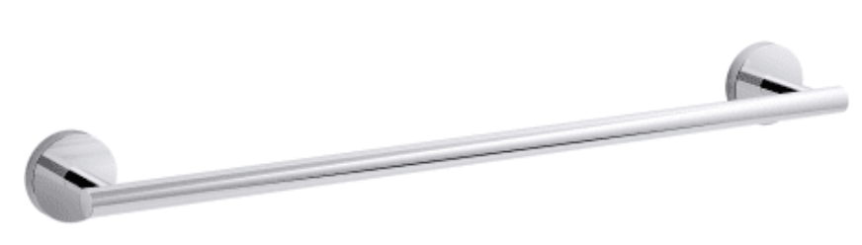 | 18" towel bar | Kohler | K-27286-CP | PC | 1
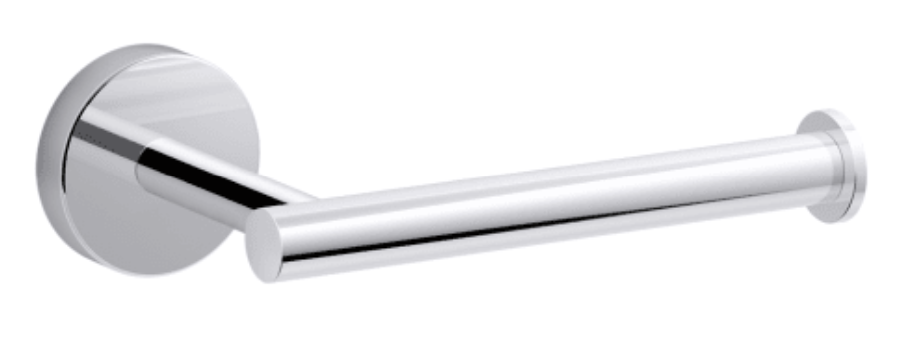 | single post TP holder | Kohler | K-27292-CP | PC | 1
 | double post TP holder | Kohler | K-37047-CP | PC | 1
MASTER BATH
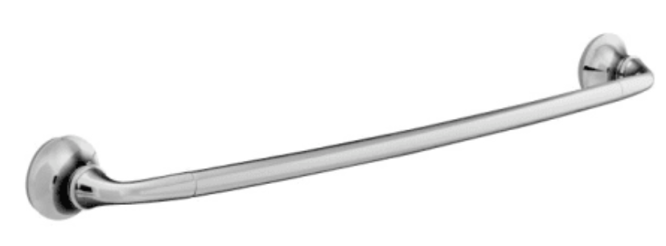 | 30" towel bar | Kohler | K-11372-CP | PC | 1
 | PC towel ring | Kohler | K-11377-CP | PC | 1
 | PC double post TP holder | Kohler | K-11374-CP | PC | 1
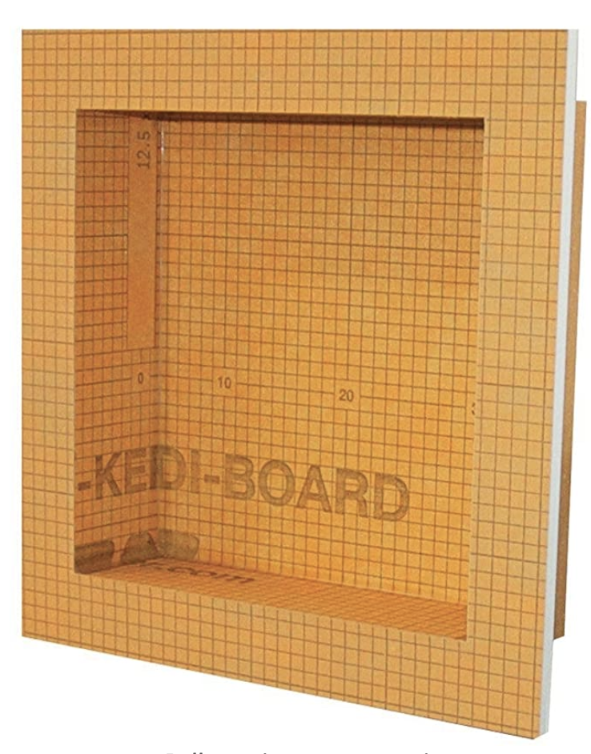 | 12"x12" Schluter kerdi shower niche | Schluter | KB12SN305305A |  | 1
BEDROOM BATH 2
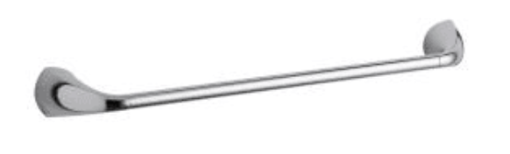 | 24" towel bar | Kohler | K-37051-CP | PC | 1
 | towel ring | Kohler | K-37057-CP | PC | 1
 | double post TP holder | Kohler | K-37047-CP | PC | 1
BATH 3
 | 24" towel bar | Kohler | K-37051-CP | PC | 1
 | towel ring | Kohler | K-37057-CP | PC | 1
 | double post TP holder | Kohler | K-37047-CP | PC | 1

10 28 19 - Tub and Shower Doors

Shower doors shall be constructed of tempered safety glass with all exposed edges polished and rounded. Swinging doors shall have vinyl seal at both the latch jamb and hinge jamb side of door.
Location: Master Bath: Frameless Glass Door: Clear. Chrome hardware.
Swing out door. Size 26"-30” wide x 72" high.
Location: Bath 2 (aka Master Bath 2nd): Frameless Glass Door: Clear. Chrome hardware.
Location: Bath 3: Kohler clear glass enclosure. Sliding doors.
Frame: Polished chrome frame Door: sliding.

10 28 23 - Laundry Accessories

Builder shall supply and install white quartz (Other color or granite samples available) countertop in Laundry Room. The design drawings locate the appliances side by side unit washer and dryer on left with countertop over them. Hanging rod and shelves over WD and hanging area.

10 30 00 - Fireplace

Pre-fabricated gas fireplaces shall be U.L. approved and installed per manufacturer’s specifications. Install units as specified below. Venting for units through chase in fireplace above and chimney through the roof with required offsets.

Manufacturer: Napoleon
Model Number: (2) x Altitude X-36 Series gas.
Unit Dimension: 34" high x 35" wide. Approx.
Location(s): Great Room and Master Bedroom.
Optional (Additional Charge Apply): 3 year extended service, fan, remote included.

10 31 13 - Manufactured Fireplace Chimneys

Chimney for prefabricated fireplace units shall be lined with 8”-10” diameter insulated metal flue as specified by manufacturer. Number of flue sections per manufacturer. Framed chimney with exterior new England fieldstone veneer finish and chimney details as noted in construction documents.

Chimney and Flue - Top of Chimney shall be located 2’-0” to 3'-0" taller in elevation than any point within 10’-0”. Flues shall be U.L. approved and installed as per manufacturer’s instructions. If multiple flues are used in the same chimney chase, an unequal projection or height of flue above the stack shall be used to safeguard against smoke exiting one flue and entering another.

10 55 00 - Postal Specialties

Builder shall install standard postal mailbox. Metal mailbox to install as per postal requirements with street number and road visible and easy to read. Install mailbox on at front of house near entry or at driveway.

Mailbox: Provided by Buyer and installed by Builder.

57 00 - Wardrobe and Closet Specialties

Install wood shelf in all closets as indicated on construction documents. Provide aluminum hanging rod, and supports every 3’-6” – 4’-0” maximum on center (OC) as needed.

Specify: 1st Floor Stair Hall Coat Closet with hanging rod and shelf.
Specify: 1st Floor Mudroom Closet with hanging rod and shelf.
Specify: 1st Floor Mudroom Utility fixed shelving/ cubbies and stand up storage.
Specify: Master Bedroom Closet 1& 2. Two built-in shelves and aluminum hanging rods each included. Additional custom storage options available.
Specify: Bedroom 1 Linen Closet. Built in storage fixed shelves.
Specify: Bedroom 1 Built in drawers. Built in drawer and or shelves.
Specify: Bedroom 1 Built in hanging closet at entry foyer including shelf and hanging rod.
Specify: Bedroom 1 Built in hanging closets in bedroom area both with shelf and hanging storage area.
Specify: Laundry built-in open shelves over WD and shelf and hanging rod on opposite wall.
Specify: Bedroom 2 Built in hanging rod and shelf above.
Specify: Bedroom 3 Built in hanging rod and shelf above.

*Custom closet designs and built-in options available through Builder upon request at additional cost.

Division 11 00 00. Equipment

31 00 - Residential Appliances

Install electric and gas appliances as per locations specified on construction documents, including all venting and fresh air supply requirements per manufacturers recommendations and applicable building codes. See electrical specifications for wiring information.

Appliance Schedule:
No | Appliance | Mfg. | Item Number | Color
1 | 36” Range – slide-in dual fuel | Bosch 800  Series | HGI18054  UC | stainless
1 | 36” Refrigerator | Bosch 800 Series | B26FT50S NS | stainless
1 | 24” Dishwasher | Bosch 800 Series | SHP878W D5N | stainless
1 | 36” Vent Hood | Vent-A-Hood | BHSLDB10 0 | insert ss
1 | Disposal | In-sinkerator | 3/4 HP | NA
1 | Washer | Maytag | MVW7230HW | White
1 | Dryer | Maytag | MED7230HW | White

Division 12 00 00. Furnishings

21 00 - Window Blinds
Available upon request for additional charge.

Venetian Blinds - Specify manufacturer, color, finish Horizontal Blinds- Specify manufacturer, color, finish Vertical Blinds - Specify manufacturer, color, finish

12 22 00 - Curtain and Drapes

Available upon request for additional charge including blocking for future use.

Fabric - Specify manufacturer, color, detailing
Backing - vinyl, fabric, lightproof
Mounting Brackets or Rods - Specify manufacturer, color, detailing
Fastenings - Rings, drapery hooks, (specify finish)

12 23 00 - Interior Shutters

Wood shutters available upon request for additional charge.

Wood / Vinyl - Home Decorators Collection or Hunter Douglas
Color, finish, panels.

12 24 00 - Window Shades

Roman Shades- Specify manufacturer, color, finish Cellular Shades - Specify manufacturer, color, finish Roller Shades- Specify manufacturer, color, finish Pleated Shades- Specify manufacturer, color, finish

12 26 00 – Available upon request for additional charge including wiring for future electronic shades.

12 30 00 - Casework

Install pre-fabricated Omega Dynasty in Kitchen, Bathrooms and other built-in cabinets at specified locations in construction documents. Dimensions of base cabinets shall be: 24” deep x 34.5” high in Kitchen and 18” to 21” deep in bathrooms. Dimensions of overhead cabinets shall be: 13” deep x 36” high. Taller overhead cabinets available at additional charge. Provide concealed softclose hinges and cabinet hardware as specified in finish schedules.

Pre-fabricated Omega & Custom on-site built-ins: See construction documents.
Finish: Pre-finished by Mtg.
Specify Kitchen: Maple, framed, beaded inset panel.
Door Style: TBD Color: TBD
Specify Pantry: Maple, framed, beaded inset panel.
Door Style: TBD Color: TBD
Specify 1st Fl ½ Bath: Maple, frameless, full overlay.
Door Style: TBD Color: TBD
Specify 1st Fl Master Bath: Maple, frameless, full overlay.
Door Style: TBD Color: TBD
Specify Bath One: Maple, frameless, full overlay.
Door Style: TBD Color: TBD
Specify Bath Two: Maple, frameless, full overlay.
Door Style: TBD Color: TBD
Specify Bedroom 1: Maple, framed, inset panel drawer fronts
Door Style: TBD Color: TBD
Specify Mudroom: Custom wood built-in bench seat.

12 36 00 - Countertops

Quartz counter tops shall be provided and installed in Kitchen / Pantry. Master Bathroom and all other bathrooms including powder room. Counter surfaces shall be fastened to cabinets or plywood as recommended by manufacturer/fabricator and installer.

Quartz counter edges shall be installed with eased edge. Additional edge profiles are available through Builder’s supplier at additional cost. 4” backsplash provided between counter and wall in Kitchen/Pantry and Bathrooms where tile is not present. Countertop samples available through Builder during Interior Design Meeting process.

Counter Top 1: Kitchen:
Venaso Pental Quartz with eased edge.
Counter Top 2: Pantry
Ventatino Guidone
Counter Top 3: Master Bathroom, Sea Pearl or Supreme White Quartz or granite TBD.
Edge: Bevel / Pencil / Eased edge.
Counter Top 4: Bathroom 1 , Sea Pearl or Supreme White Quartz or granite TBD.
Edge: Bevel / Pencil / Eased edge.
Counter Top 5: Bathroom 2, Sea Pearl or Supreme White Quartz or granite TBD.
Edge: Bevel / Pencil / Eased edge.
Counter Top 6: Half Bath, Sea Pearl or Supreme White Quartz or granite TBD.
Edge: Bevel / Pencil / Eased edge.
Counter Top 7: Laundry, quartz or granite TBD white approx. 6’ x 30”.
Edge: Bevel / Pencil / Eased edge.
Bench Seat 1: TBD quartz or granite
Edge: Bevel / Pencil / Eased edge.
Bench Seat 2: TBD quartz or granite.
Edge: Bevel / Pencil / Eased edge.

* Countertops listed above supplied and installed exclusively through BG supplier. BGD supplier carries extensive selection of styles and colors of quartz, quarzite, granite, and marble countertops. Substitutions may be possible based on price and availability.

Division 22 00 00. Plumbing

22 00 00 - Plumbing

Plumbing shall be a fully operational system of hot and cold water. Provide and install all piping, soil, vents, drains, sewage removal and water supply systems to connect with appropriate water and sewage systems for 1st and 2nd floor living areas. Provide and install appropriate insulation around piping surrounding main living areas. All permits and inspections are to be obtained by Developer and Builder and Plumber as required by local building codes and the Uniform Plumbing Code.

Sewer and Waste Piping - Drainage system shall be Schedule 40 PVC pipe. All connections shall have PVC cement or appropriate joint compound and assembled tight for no leakage. Condensate drains for mini-split heads shall be constructed of Schedule 40 PVC or PEX tubing. Valves shall be Milwaukee Brand or equal. Building sewer shall be approved Schedule 40 PVC pipe. Connection to public sewer system shall comply with all local requirements. Caulk joints or provide neoprene gaskets for all sewer lines. Pitch shall be a minimum 1/8” per foot for soil lines larger than 3” diameter and a minimum of 1/4” per foot for soil lines 3” diameter or less.
Interior drain/waste piping insulated with batt insulation for sound attenuation.

Water Pipes - From public water line, install Type “L” or “K” 1" copper pipes, located below frost line. From the meter to the building, install 1" supply water lines. Use 1/2” and 3/4” PEX minimum lines from supply lines to each plumbing fixture as required. At water heaters and hose bibs install a minimum 1/2" and 3/4” pipe. From water heater install 1/2" and 3/4” pipe to each room with branches to fixtures as described above. Fittings shall be wrought copper or PEX, soldered with 95-5 solder and suitable flux. Use polished chrome adjustable brass P-traps with wall escutcheons at all exposed locations.

Provide shut-off valves at sinks, toilets, water heater and other fixtures as required. Test all pipes under pressure per building code requirements.
Waste Drainage - Install sewage clean-out at the end of each horizontal drainage run and every 100 feet per building code requirements. Vents shall be installed throughout plumbing connections and connected with the vertical stacks and vented through the roof. Check with local building code officials for specific venting requirements.

Water Heater - Install one 80 gallon Lochinvar or equivalent indirect gas fired hot water heater. Water heater shall be heated by condensing boiler and have appropriate safety valves, back flow preventers, pressure relief valves and drain assemblies. Install Type “X” fire-rated gypsum wallboard surrounding gas water heaters as needed only. Follow manufacturer recommendations and building code requirements for installation and use

Specify: indirect gas fired
Specify Powder: Lochinvar indirect 80-85 gallon storage tank.

40 00 - Plumbing Fixtures

Provide necessary piping, water and drains for plumbing fixtures either as shown on the construction documents or listed herein.

Fixtures and Fittings - Provide and install plumbing fixtures as listed below.

Location | Fixtures | Qty | Descrip. | Model
Kitchen | Sink SS | 1 | 32” x18”x9” undermount | Kohler Sterling 847937
Kitchen | Faucet PC | 1 | Simplice 1 hole deck mount single lever handle with pull down spout. | Kohler 770793
Pantry | Sink SS | 1 | 16” x 18” x 8” undercounter prep sink. | Kohler 729057
Pantry | Faucet | 1 | Simplice lever HDL Prep faucet | Kohler 1851667
Master Bath | Univ Valve | 1 | Right temp pressure balanced | Kohler 1606501
Master Bath | Master shower | 1 | 2 or 3 way transfer valve. | Kohler 929281
Master Bath | Shwr Fct Trim | 1 | Shower faucet trim | Kohler 2318710
Master Bath | Shwr transfer valve | 1 | Trim | Kohler 2325184
Master Bath | Body spray | 2 | Statement round Adj. 26299-G-CP | Kohler 2313621
Master Bath | Handshower | 1 | K-99898 PC Awaken | 1886941
Master Bath | Handshower supply elbow | 1 | Awaken Supply Elbow K-98350-CP | Kohler 1314254
Master Bath | Kohler 971299 | 1 | White Highline WC comfort height | Kohler 971299
Master Bath | WC seat | 1 | Cachet plastic seat w cover | K-4636
Master Bath | Sink | 1 | Undercounter sink | Kohler 20,000-1
Master Bath | Faucet | 1 | Venza PC sink faucet | Kohler 28125-4-CP
Bath 2 | Shower valve | 1 | Univ rite temp pres bal valve kit | Kohler K-P88304
Bath 2 | Shower trim | 1 | Simplice shower faucet trim | Kohler TS27392-4G-CP
Bath 2 | Sink | 1 | White oval bowl undermount | Kohler 74490
Bath 2 | Bath faucet | 1 | Simplice PC | Kohler 27390-4-CP
Bath 2 | WC | 1 | Highline 2 piece comfort height elongated WC | K-3999-0 white
Bath 2 | Toilet Seat | 1 | Quiet close elongated | Kohler 4636-RL-0
Bath 3 | Shower valve | 1 | Univ rite temp pres bal valve kit | Kohler K-P88304
Bath 3 | Shower trim | 1 | Simplice shower faucet trim | Kohler TS27392-4G-CP
Bath 3 | Sink | 1 | White oval bowl undermount | Kohler 74490
Bath 3 | Bath faucet | 1 | Simplice PC | Kohler 27390-4-CP
Bath 3 | WC | 1 | Highline 2 piece comfort height elongated WC | K-3999-0 white
Bath 3 | Toilet Seat | 1 | Quiet close elongated | Kohler 4636-RL-0
Half Bath | Sink | 1 | White oval Caxton 17x14 undermount | Kohler 2210-0
Half Bath | Faucet | 1 | Bellera PC 2H WS DM Bath faucet | Kohler 27380-4-CP
Half Bath | WC | 1 | White Highline 2 piece comfort height elongated | Kohler 3999-0
Half Bath | WC Seat | 1 | Closed front elongated seat | Kohler 4636-0

Division 23 00 00. Heating, Ventilating, and Air Conditioning (HVAC)

09 00 - Instrumentation and Control for HVAC

Install digital radiant thermostats Tekmar 519 on 1st and 2nd floors of house (2). Zone heating by floor and AC by room with mini-split heat pumps. The location of controls shall be coordinated to avoid conflicts with furnishings or uses for the rooms in which controls are located. AC controls mounted at entry of rooms with head units for convenience.

23 31 00 - HVAC lines, refrigerant lines, and condensate lines

Layouts for lines shall be determined on-site as not to interfere with finished ceilings.

23 54 16 - Gas-Fired Furnace

HVAC unit shall be a high efficiency minimum 85,000 BTU 95% high efficiency gas condensing boiler. The system will contain water distribution pipes, backflow preventers, valves, pumps, and thermostats. Provide necessary venting and fire-rated wall system around furnace as needed.

23 70 00 - HVAC Equipment - Electric Heat Pump Mitsubishi / Fujitsu / Samsung mini-splits.

AC shall be a fully operational designed to meet individual room needs. All permits and inspections shall be obtained by mechanical contractor as required by applicable building codes. The system will contain concrete pads to support condensers located outside, power disconnects, drain lines, and refrigerant lines. The home will be zoned by individual rooms and areas on each floor based on equipment specifications and load calculations. Heads for AC will be located in all bedrooms (4) and main living rooms (3) distributed optimally throughout First Floor and Second Floor areas.

23 83 00 - Radiant Heating Units

Complete installation shall conform to appropriate local codes and shall also be in accordance with manufacturer’s specification. Aluminum PEX heating tubes shall not leave heated area.

Directly embed heat PEX in 3-4"-inch concrete slab located in basement floor (excluding storage closet) and garage floor for the future. Basement and garage floor heating will not be activated but will be available should these areas be insulated and finished in the future. Heat tubing will be placed directly in radiant panels throughout 1st and 2nd floors for active heating. Manifolds will be installed in basement for first floor heat and 1st floor for second floor heating at predetermined accessible mechanical closet/cubby locations for efficient distribution of hot water. DO NOT PENETRATE FLOORING FOLLOWING INSTALLATION OF HOT WATER LINES.

Division 26 00 00. Electrical

26 27 26 - Wiring Devices

Install beige, white, brass receptacles, switches and cover plates as per code requirements. A walkthrough with Buyers, Builder, and electrician will be scheduled prior to rough-in commencement to ensure convenience outlets and light switches are installed according to Buyer’s preferences. Additional devices including switches and receptacles may be added for convenience on a per unit cost basis. For exterior receptacles install gray shingle box cover plates. When two or more switches or receptacles are located together, gang with one common. All receptacles shall be placed according to code requirements.

26 50 00 - Lighting

Provide necessary circuits and wiring for light fixtures as listed below. All lighting shall be switched as per code requirements for safety first and foremost. As similar to Wiring Devises personal preferences may be incorporated into the build as identified during walk-through with Buyers, Buider, and Electrician following framing for lighting preferences and placement of lighting fixtures including recessed lights. Fixture lists are listed below.

Special Items - Provide necessary receptacle requirements and wiring for additional items as listed below. Locate as per code and convenience locations as per scheduled walkthrough with Buyers.

Bath Vent Fans - install fans in all bathrooms. Panasonic programable Whisper Green for whole house ventilation will be installed in at least two bathrooms.
Thermostat/Control - install for all mini-split wall units at each location and radiant digital control on each floor with exterior reset.
Smoke, Heat, & CO Detectors - install per fire code at bedrooms and common areas.
Doorbell - located at front door with chime centrally located.
CATV - located in Great Room, Kitchen, Master Bedroom, and bedrooms. Precise locations for low voltage receptacles during walkthrough. Wireless data signal distribution and devices utilized to boost signal available upon request at additional cost along with speaker wire, and other low voltage wiring for home entertainment and communication purposes. Telephone lines tied in by phone company or private contractor of your choosing following move in.
Garage Door/ Overhead Door opener - locate ceiling connection for door lift device and push button at entries by LiftMaster.
Security System - pre-wire for security system available upon request for additional cost.

Fixtures - Provide and install electrical fixtures in general location listed below. Additional allowance has been made for 25 recessed lights to be installed on combined 1st and 2nd floors. Precise locations to be determined at walk-through with Buyer following framing and partitioning. Recessed light fixtures by Juno or Lightoliere 4" or 5" diameter. Exact location of fixtures noted below also to be determined at walk-through following framing. Fixture Mtg Progress Lighting and Millennium Lighting.
Interior Areas:

(Examples below)

Stair Hall | 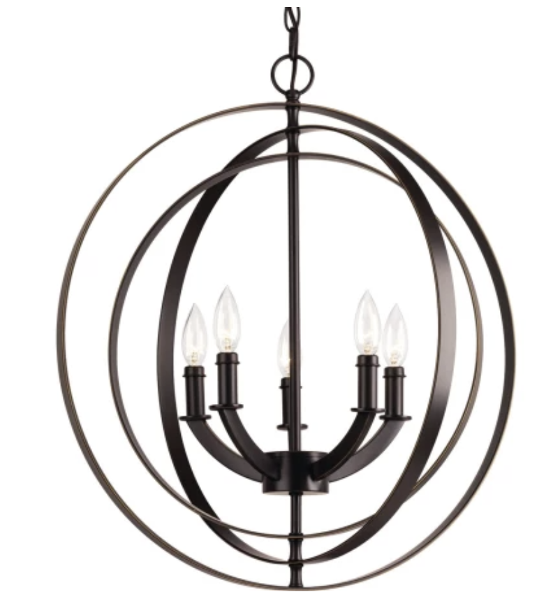 | (1) 22" globe chandelier, antique bronze (finish options:  black, burnished silver, polished nickel, satin brass)
Dining | 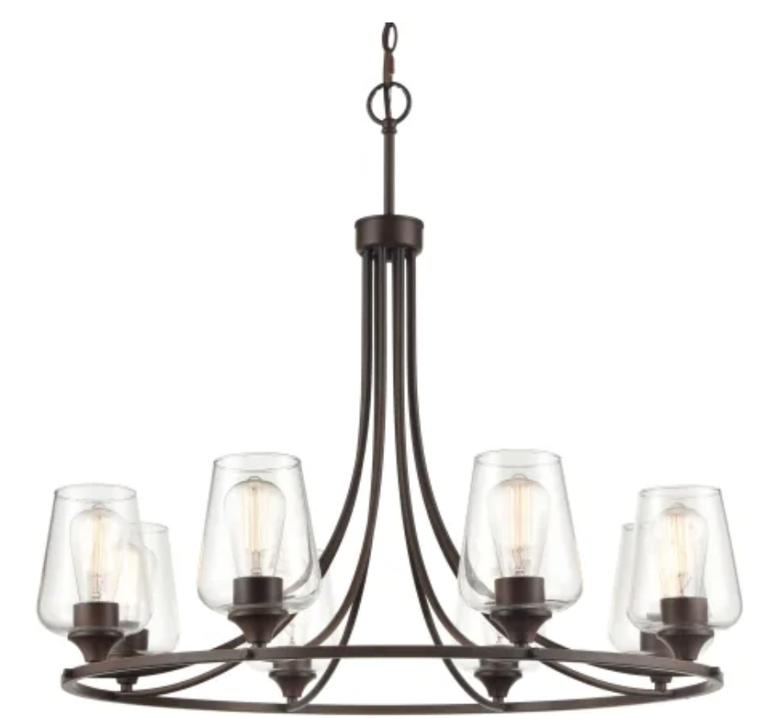 | (1) 8 light 32" wide chandelier, rubbed bronze (finish options: black, satin nickel)
Kitchen | 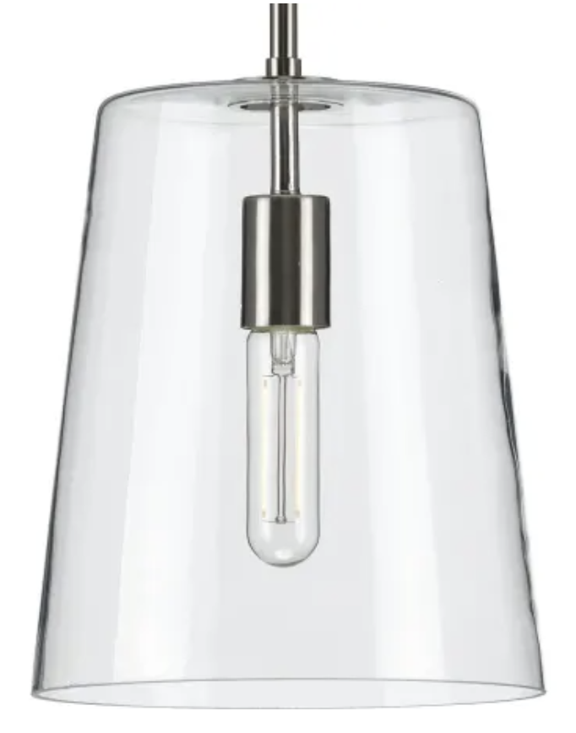 | (2) 9" wide glass shade pendants, satin brass (finish options: matte black, polished nickel, brushed nickel)
Bedroom 2 | 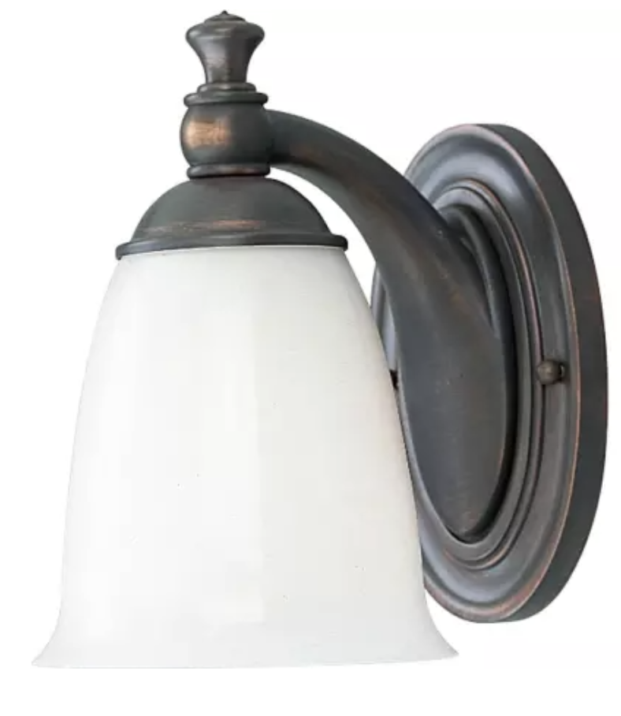 | (2) 9" tall wall sconce, opal glass shades, venetian bronze
Master Bath |  | (1) 16" wide vanity light, 2 round clear glass shades, polished nickel (finish option: antique bronze)
Bath ("guest") | 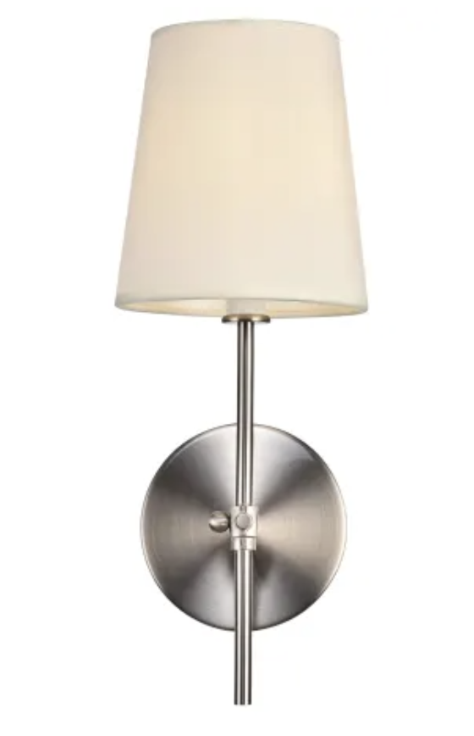 | (2) 15" wall sconces, linen shades, burnished nickel (finish options: black, brass, brass plate with black stem)
Master Bath 2nd Fl. | 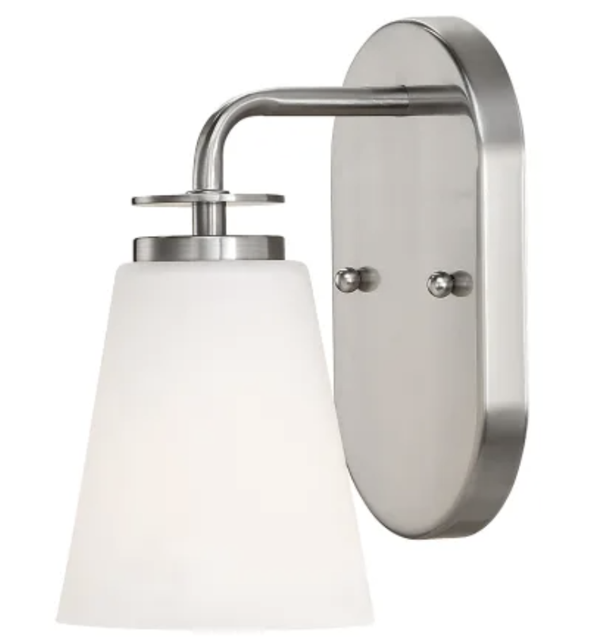 | (3) 9" wall sconces, etched glass shades, satin nickel
Master Bed | 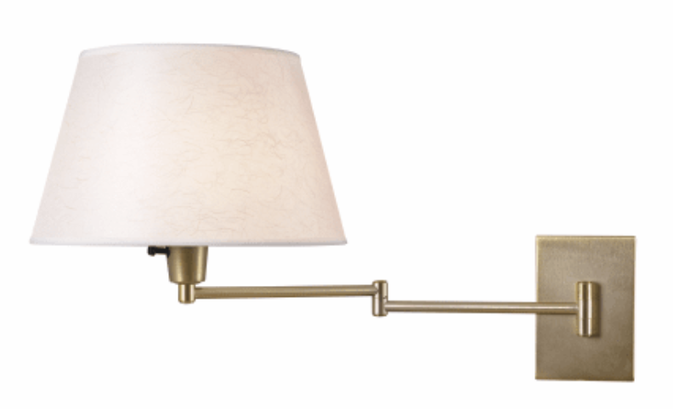 | (2) swing-arm sconces, white shades, vintage brass finish (finish options: oil rubbed bronze, polished brass)
Hallways / Great Rm | 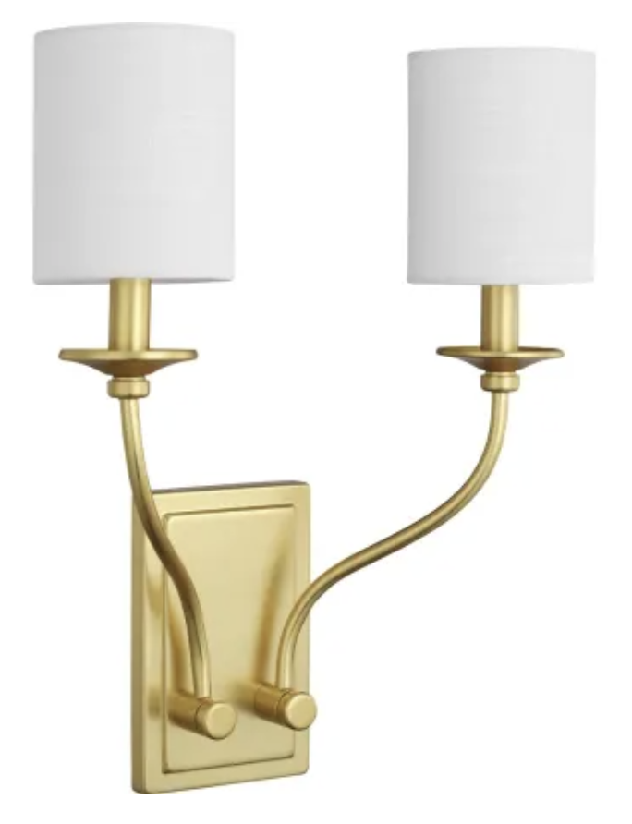 | (4) 17" tall wall sconces, white shades, satin brass finish (finish options: antique bronze, brushed nickel, matte black, polished chrome)
Mudroom | 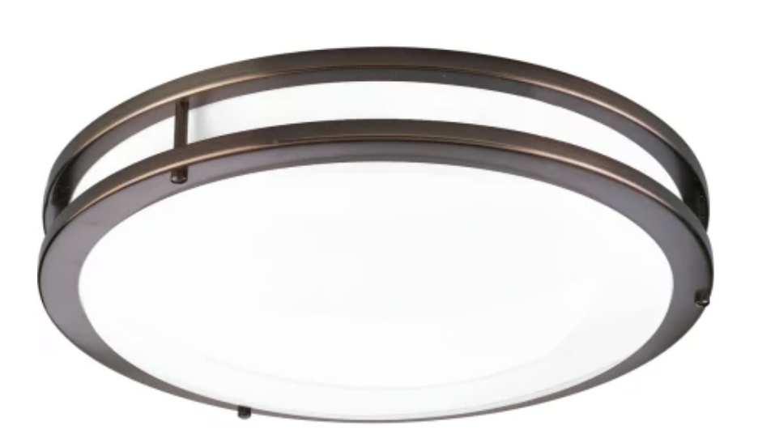 | (1) 14" round flush mount, white acrylic diffuser, urban bronze finish (finish option: brushed nickel)

Exterior Areas:

Between garage doors | 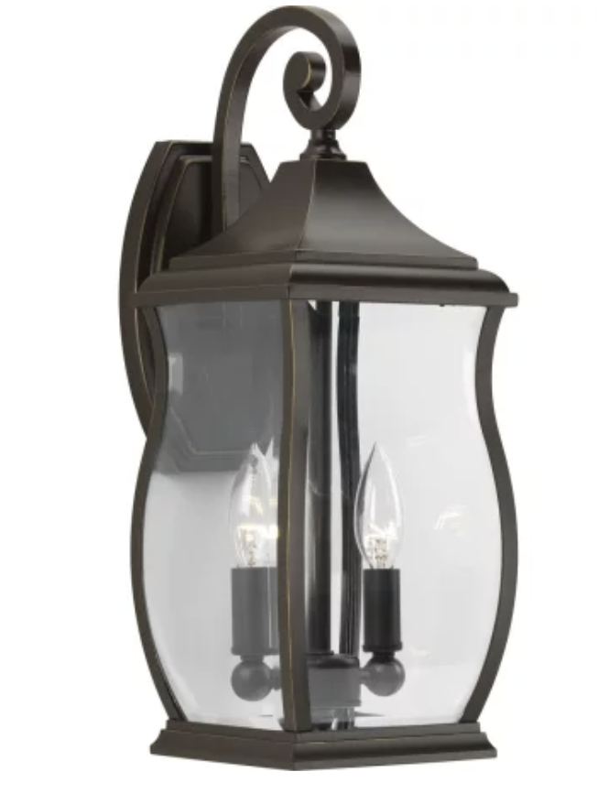 | (1) 18" tall lantern-style 2-light sconce, oil rubbed bronze
At Entry Door | 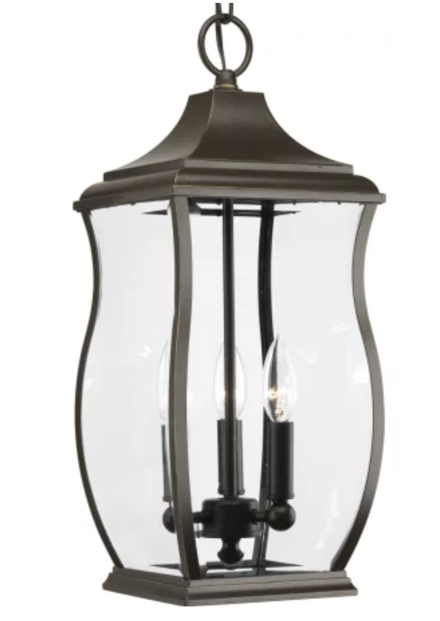  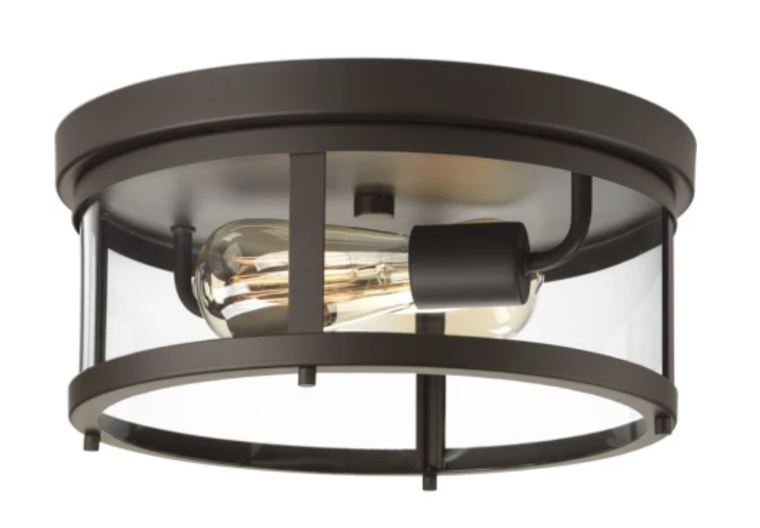 | (1) 19.75" tall lantern-style 3-light pendant, oil rubbed bronze
At Mudroom Door |  | 13" round 2-light flush mount, oil rubbed bronze
At Back Entry Doors | 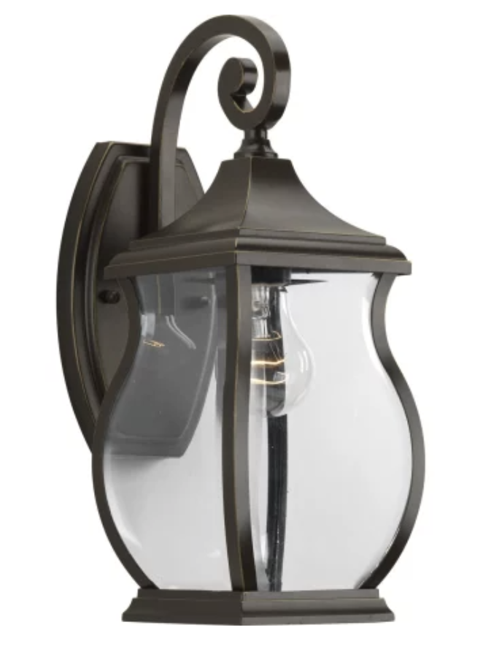 | (3) 15" tall lantern-style single light sconce, oil rubbed bronze
Back Patios | 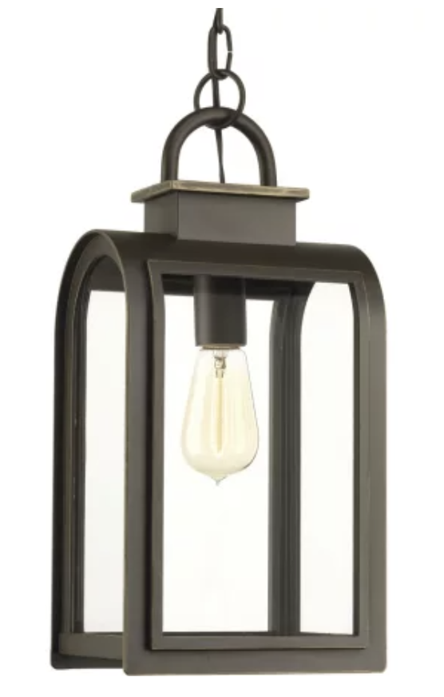 | (2) 16" tall one-light pendant, oil rubbed bronze
Flanking 2nd Floor Balcony Doors | 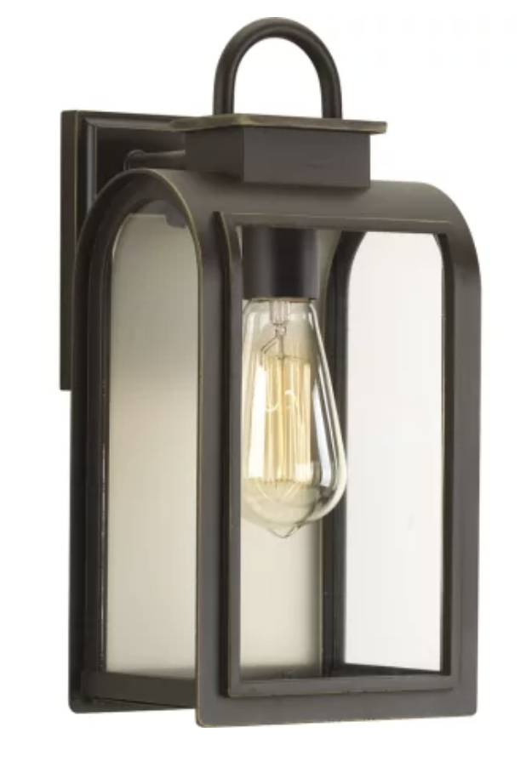 | (2) 13" tall single-light sconces, oil rubbed bronze
Side Entries | 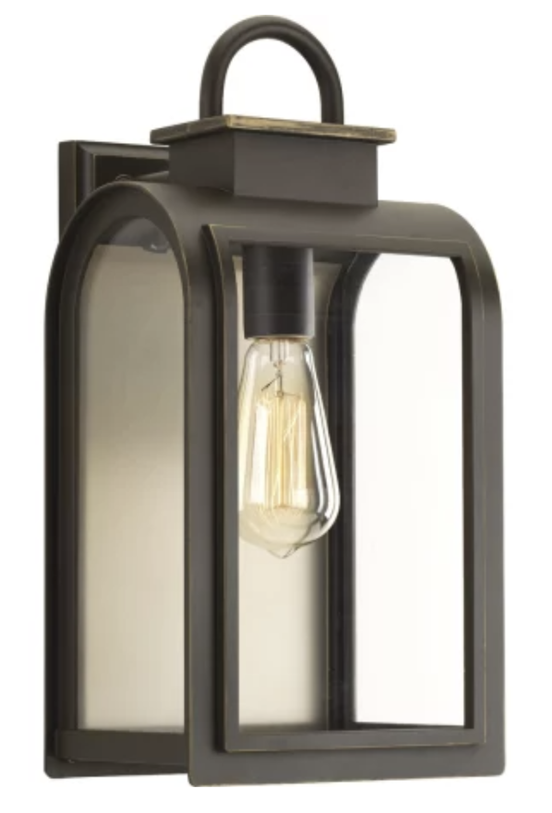 | (2) 16" tall single-light sconces, oil rubbed bronze

Division 32 00 00. Exterior Improvements

01 90 - Operation and Maintenance of Planting

All plants shall be planted and kept in healthy, growing condition by watering, weeding, cultivating, pruning, spraying, trimming, protection from wind, and by performing any other necessary operations or maintenance for a period of 30 days prior to closing or until acceptance of the planting at the time of the final inspection. A final weeding of all plant areas shall be made immediately prior to final inspection. Newly planted trees shall be cared for and pruned as necessary. All dead branches shall be removed. Rootstock shoots from grafted material shall be removed.

32 01 90.13 - Fertilizing

Soil conditioners and natural additives including Coast of Maine, cow manure, etc will be incorporated in planting areas and sod applied to heavily disturbed areas by clearing operations. Soil conditioners and fertilizers will be spread as needed and thoroughly incorporate by rototilling work into topsoil to a depth of 4”. Topsoil will be raked until the surface is finely pulverized and smooth with aggregate of 1/4" or smaller remaining only.

Plantings | Name - Species | Qty | Location
Canopy Tree | Red Maple | 1 | Front yard
Understory Tree | Bradford Pear | 4 | (1) Front, (2) Back
Winter gem | boxwood | 8 | (4) Front, (4) Back
Evergreens | Colorado Spruce or Leland Cyprus | 8 | South side privacy plantings
Canopy Tree | River Birch 8-10’ | 3 | North east and south east corners
Understory Tree | Eastern Redbud | 1 | west side

Canopy Tree | Copper Beach 6-8’ | 8 | East side
Canopy Tree | American Beach  8-10' | 3 | along Ware Lane
Evergreen | Arbor Vitae | 12 | East side assorted privacy
Misc | assorted | 24 | flowers, plants, front yard and rear yard

06 00 – Fence

NA

32 12 16 - Asphalt Driveway

Sub-base materials shall Lynn pack stone below finished driveway. The base course shall be bituminous concrete consisting of course and fine aggregate combined with asphalt cement, resulting in a mixture of Type BM-2. The surface course shall be bituminous concrete consisting of crushed stone, crushed slag or crushed gravel and the fine aggregate slag or stone screenings or combination thereof combined with asphalt cement, resulting in a mixture of Type SM-2A.

Asphalt Installation - Areas to be paved shall be covered with a layer of hot asphalt concrete surfacing not less than the thickness indicated after compaction (ex: compacted thickness shall be 2 inches binder and 2 inches of finish, driveways and aisles of parking areas). Paving asphaltic concrete shall be delivered, laid, rolled and finished in accordance with local guidelines. Finish paving shall conform to slopes, lines and finish grades as, and drain properly.

*Paver driveway upgrade option available at additional cost. See Builder for options if interested.

32 13 13 - Concrete Pads and Walks

Provide light duty paving at exterior walk areas consisting of a 3" thick slab on sub-grade compacted to 98 percent density with 3000 psi concrete. A 2" thick thermal bluestone landing will be installed at front entry and side porch area. Back porch/terrace will be thermal bluestone installation. Refer to floorplan for additional information. Expansion joints shall be installed as in standard concrete practices for all concrete walkways. Control joints shall be installed at pre-determined locations no later than 12 hours after installation.

32 14 00 - Paver Terrace & Front Walk. Bluestone Steps.

Install thermal bluestone at entry, side porch, and rear terrace area over well compacted aggregate / ground soil and backfill with dense graded aggregate suitable for sub-base material (ex: sand), typically 4”. Sand shall be screened to proper pitch and height so that final installation will result in proper surface drainage. Set with mortar joints. After installation wash access mortar from joints.

Color: PA Bluestone
Finish: level with slight pitch away from house.

Paver terrace and landings at front and side areas including entries and NE fieldstone veneer risers and veneers at Entry.

32 84 13 & 23 - Drip Irrigation & Underground Sprinklers

Low pressure water system with buried or sub-surfaced pipes. Install as recommended by manufacturer.
Install irrigation system consisting of valves, water lines, sprinkler heads and control panels to adequately cover sod and plant beds. Install as recommended by manufacturer. electronic valves. Irrigation water deduct meter will be installed in the basement besides regular water meter.

32 92 19 - Seeding

Seed only when weather conditions are suitable at side and rear yard areas. All newly seeded turf areas shall be free of broadleaf weeds. Sow seed with mechanical spreaders at the specified rate on a calm day. Sow one half the seed in one direction and the other half at right angles. Seed shall be raked lightly into the soil to a depth of 1/4 inch. Keep the surface moist by a fine spray until the grass shows uniform germination over the entire area. Wherever poor germination occurs in areas larger than three (3) square feet, reseed, roll and water as necessary to obtain proper germination. Infested areas shall be treated with a selective broadleaf insecticide; Trimec or approved equal.

32 92 23 - Sodding

Plant only certified sod in front yard areas facing Ware Lane when the soil is moist and favorable for growth. Shape the area to be sodded and finish to the lines and grades indicated on the plans. Loosen the surface prior to placing sod. Keep the grade moist by sprinkling, if necessary, sod on the prepared surface with the edges in close contact. Each piece of sod laid shall be fitted and tamped into place with hand tampers. Apply a sufficient quantity of water to all sod after laying and to prevent the sod from drying out for a period at least two weeks to ensure growth.

